**Tune the database configuration settings (e.g., shared buffers, checkpoint settings) to improve query performance, and compare the results before and after the tuning.**

SELECT c.name, COUNT(b.id) AS num_books, AVG(b.price) AS avg_price

FROM category c

LEFT JOIN books b ON c.id = b.category_id

GROUP BY c.name

HAVING num_books > 10 AND avg_price > 50;

Default settings:

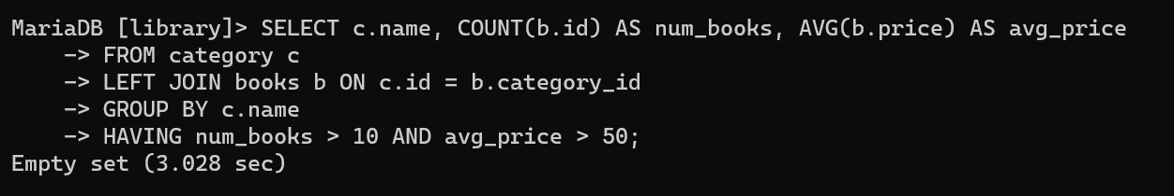

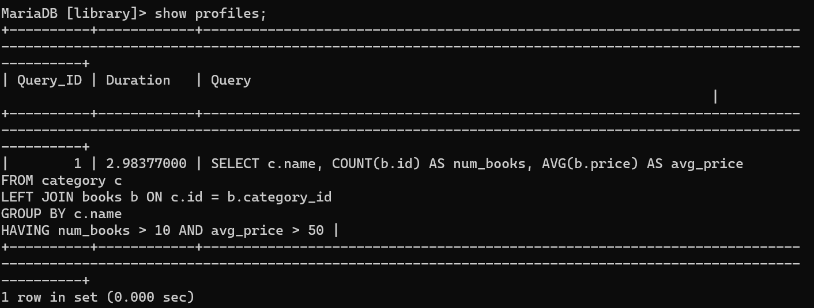

Increasing buffer_pool_size to 512M:

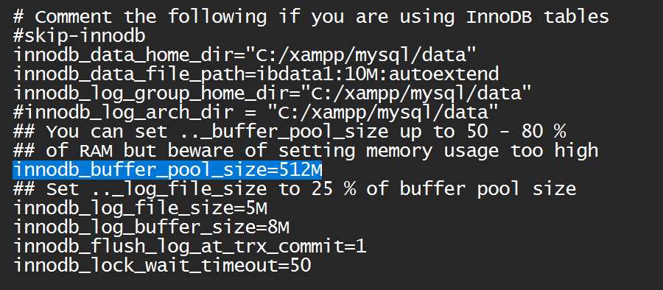

Decreases the execution time slightly:

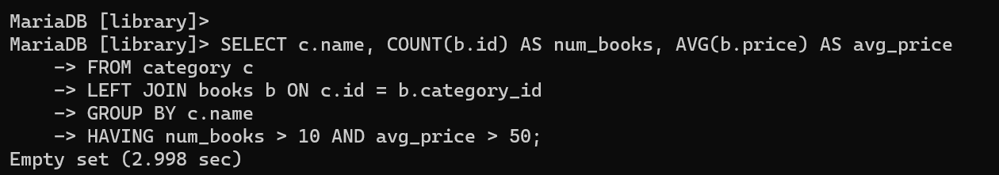

Increasing pool size further reduces execution time:

